SV NEVER DIE WONDERING II 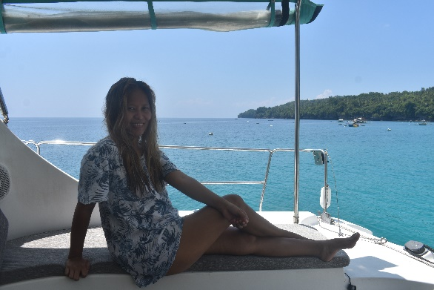 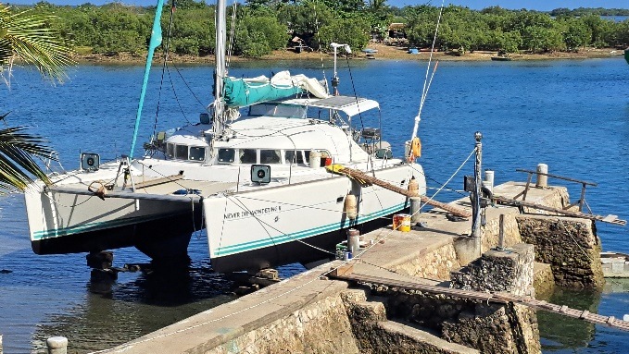
Exotic Lovely Jane in name and nature Zekes yard Cebu anti fouling
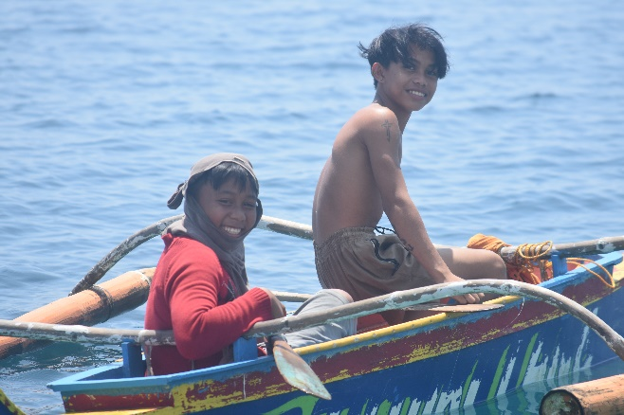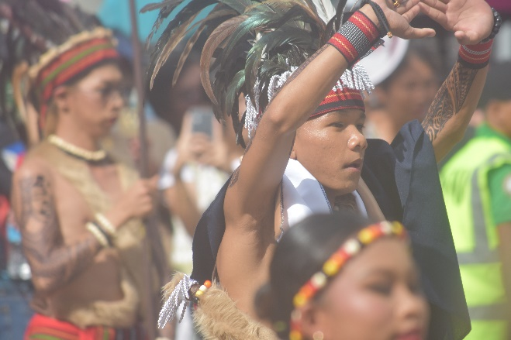
Happy Children of the Islands Culture festival Davao
Voyage 2024
Samal Island to Cebu
At present I am at Cebu in the Philippines, were I needed to dry dock my vessel for a well overdue bottom paint [anti fouling]. I have recently sailed from Samal island in the southern region of Mindanao of which is the second largest island in the Philippines along the surf coast to the Island of Siargao. The passage of which I did solo had taken several weeks to complete as torrential rains had created flooding conditions and therefore visibility was very poor resulting in playing safe by staying in anchorages longer than expected. It seems every part of the coast has fishermen and Fishing Artificial Devices [FAD] what are a navigation hazard and I have personally had several near misses. So, it’s an easy decision not to sail at night and only when visibility is good. Sailing northerly, you are in the Philippine’s trench that can be as deep as 10 kilometers and the current is strong and against you, along with a north easterly wind on the nose makes sailing unpleasant at times to say the least.

“The Hardest sailing is the sailing you make alone,
but it’s the sail that makes you strong, confident, Independent and fearless”
I did not see the sun for many days, and it seemed every day I was a repairing the rough conditions created the entire saloon cabinet and sofa to break away from the floor, the exhaust hose split flooding sea water into the stern. Starter motor replacement, anchor winch maintenance and sailing close to breaking surf while coming into an anchorage with stormy conditions destroying visibility? You start to question yourself as what are you doing here? Then the sun comes through the clouds and the seas and wind are fair and you watch the dolphins ride the bow waves and you quickly forget the previous hardships. “The best place to be is here, and the best time to be here is now
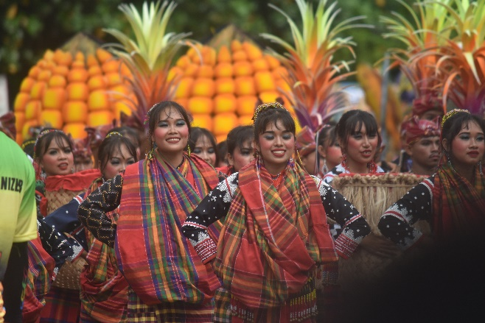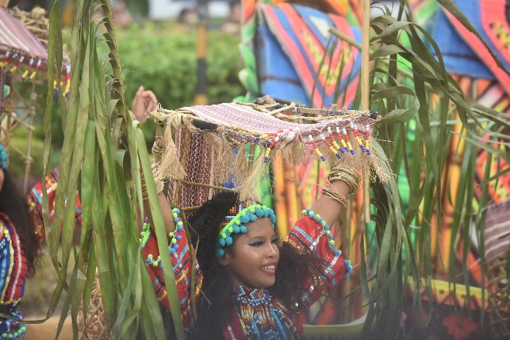
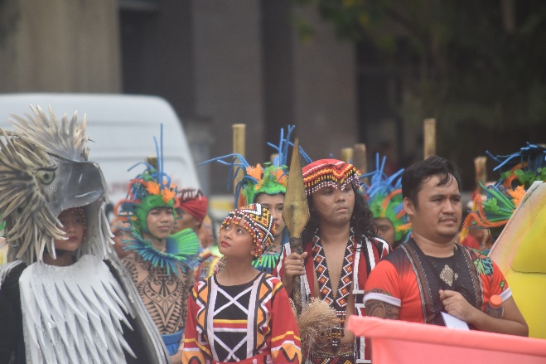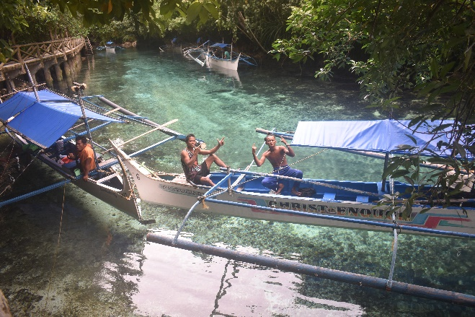
Samal Island
I spent the typhoon season on Samal island as it is 7 degrees north of which is in the none typhoon region, while there, I was able to do a re-fit of the vessel furniture replacement inside and out, timber work bringing it back to life bulk head repairs and writing my memoirs for my third book exploring this incredible country with the most friendly of people. There is over 17 million indigenous people through the 7,000 islands of the Philippines with 110 ethnolinguistic groups. Most retain their culture as you can see in the photos of one of the many cultural festivals held throughout the year. There is a large bat cave on the island home to the Monfort bat of which is a fruit bat, smaller than the Australian version the colony is believed to be 2.3 million and I could see a large lace monitor lizard enjoying his lunch of bats at the base of the cave. During the second world war the Japanese invaded the island and the locals were subjected to horrendous abuse by the invaders, a family hid deep into the cave and lived with the millions of bats to avoid capture, its hard to imaging as the heat and smell would have been terrible.
“I had inheritance from my father, it was the moon and the sun and although I roam all over the world the spending of it is never done”
Ernest Hemingway
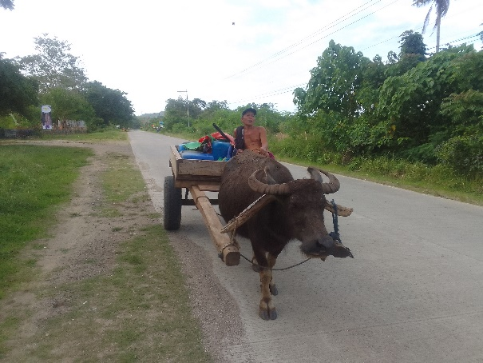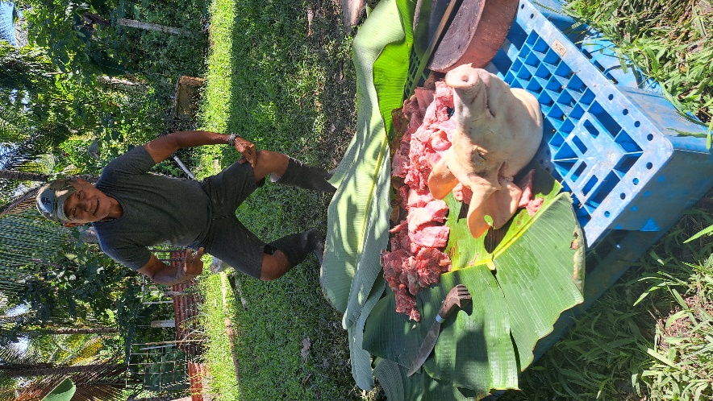
Water buffalo are becoming rare transport Baboy cook up Samal Island
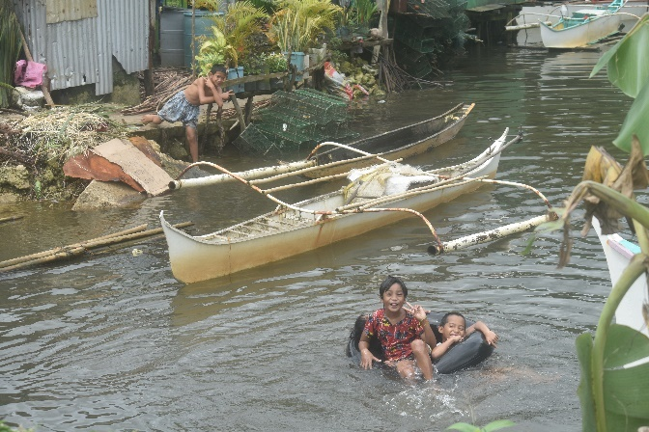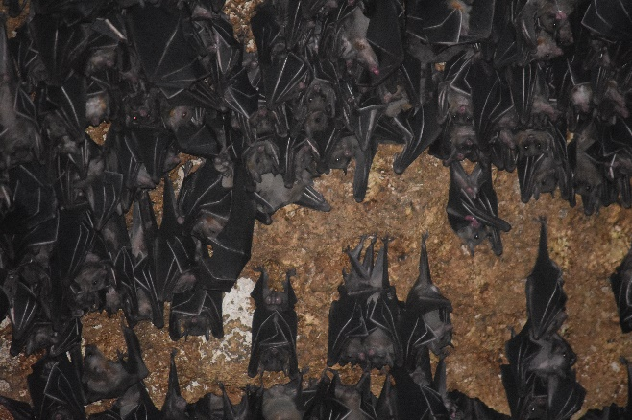
Happy Children Siargao Island Monfort Bats
I have become accustomed to Philippines food from adobo chicken cooked in sauces or their barboy lechon [Baboy meaning Pig and lechon BBQ] the villages in the evening are smoky places whereby the people are on the streets enjoying the BBQ delights. Cock fighting is a national sport were someone with a good fighting bird can reap some serious money in winnings, considering Philippines wages are as low as $12 Australian dollars a day. nothing goes to waste during these cock fights meat is taken and even the feathers are sold by vendors in the streets for feather dusters While in Mati Bay on the south Eastern side of Mindanao local fisherman took me out to their nets to collect their catch. They incredibly swim into the nets funneling the fish and diving under the water collecting all types of fish along with prawns’ crabs and puffer fish that are very poisonous, but they have skilled older people who remove the poisonous parts and they cook it a unique way, I passed on the eating of these fish but enjoyed the prawns and crabs. The fisherman worked the mangroves and collect mud crabs and house them in a log with in a large, netted area, were by the feed them up and sell them to the cities. While watching the divers work one became severely bitten by jelly fish and we had to quickly get him to the yacht for vinegar treatment to reduce the sting.
The flooding along the coast was horrific several people had lost their lives in landslides, and I tried to obtain fuel only to discover the fuel stations were covered in a meter of water? And to add to the adventure there were earthquake warnings with the potential threat of a tsunami that becomes a little concerning while out at sea.
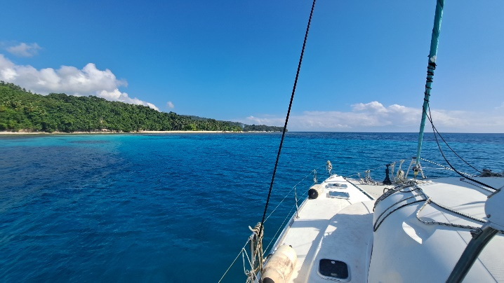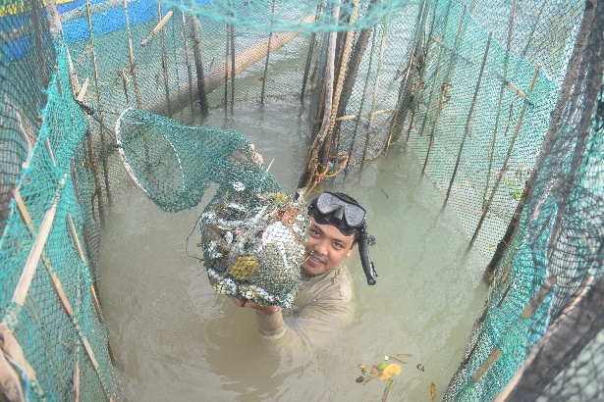
Samal Island Net fisherman Mati
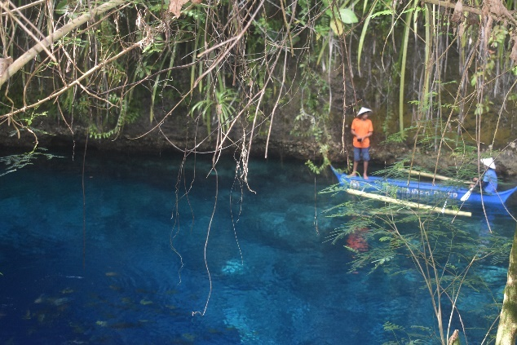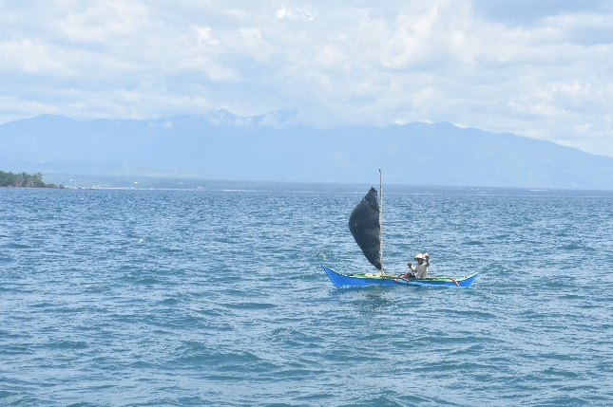
Enchanted River Fisherman under sail

The Enchanted River is a crystal clear freshwater stream that flows from a deep pool of which the depths is unknown hence the name enchanted due to either no one reaching the bottom or legend has it the river is haunted by supernatural beings that act as a protector and if you swim at night you will disappear. I anchored as close to the river as possible and reached it by my tender.
“When something good happens travel to celebrate,
When something bad happens travel to forget it,
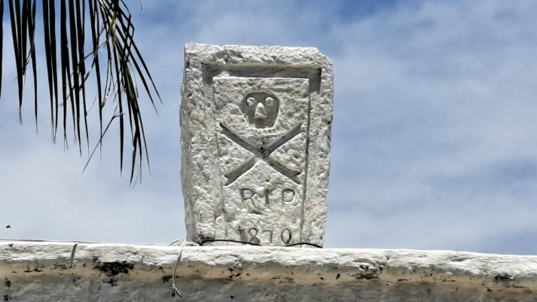
If nothing happens travel to make something happen”
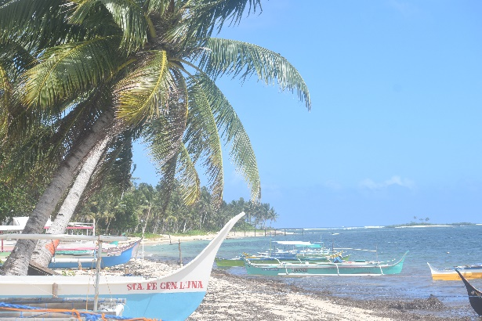
Spanish era burial site Surf island of Siargao
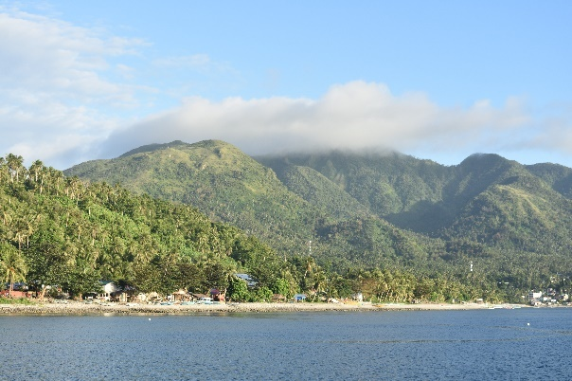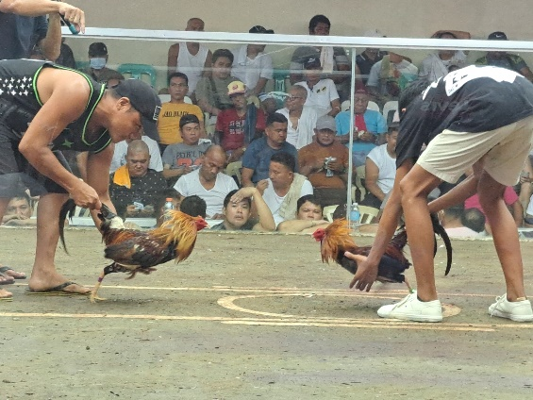
Exotic islands Cock Fighting
Once you sail to the islands around Cebu there are many signs of the Spanish occupation that took part between 1565 to 1898 by way of forts and churches, the photo provided of the skull and cross bones 1870 carved into a stone is that of a burial site. And it was here in Cebu that Ferdinand Magellan the Portuguese explorer who was the master mind behind the first circumnavigation of the world was killed after receiving a poisoned arrow to his right leg, Personally I have only meet welcoming people with no arrows being fired? Magellan must of upset the locals?
I am now planning to continue to explore the exotic islands of this incredible archipelago and make my way to Palawan the island bordering the South China sea.

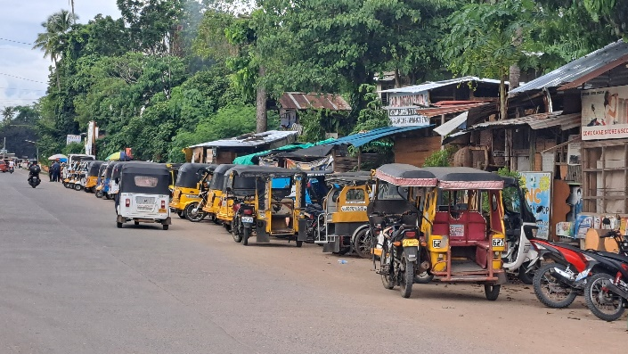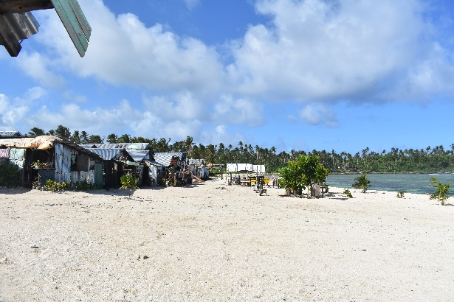
Babak Samal island Village Siargao island
“An adventurer, a free-spirited person must never conform to other people’s expectations. It is essential to live your dreams, to explore and to discover.
Anything less would eventually lead to a life of regret.
Pursue the ultimate- goal to NEVER DIE WONDERING.”
Alistair J MacLeod
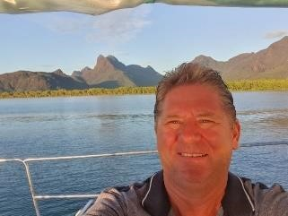
Never Die Wondering

c

gshEe

Kind regards
Alistair Macleod
If you wish to unsubscribe reply unsubscribe
…………………………………………………………………………………………………………………………………………………………...
Never Die Wondering ebook and Son of a highlander at www.neverdiewondering.com.au along with past newsletters.
………………………………………………………………………………………………………………………….
Copyright ajmacleod.com . All rights reserved. Newsletter Design Alistair MacLeod
……………………………………………………………………………………………………………………………………………….

